CUSTOMER CONTACT: |  | PREPARED BY:
COMPANY NAME: |  | DATE:
ADDRESS: |  | EMAIL:
 |  | PHONE:

VALVE DATA
RPM: |  | CAPACITY: |  | STAGE 1 | STAGE 2 | STAGE 3 | STAGE 4
NO. OF SUCTION VALVES PER CYLINDER END
NO. OF DISCHARGE VALVES PER CYLINDER END
TOTAL NO. OF VALVES PER CYLINDER
SUCTION VALVE UNLOADERS – F - FINGER or P - PLUG |  |  |  | F or P | F or P | F or P | F or P

DESCRIBE PROBLEMS AND OPERATING LIFE | FREQUENCY OF PROBLEM
BROKEN PLATES SPRINGS SEATS  DIRT CRUD CAPACITY  SALT STRESS CRACKING OTHER | (DAYS,WEEKS,MONTHS, etc.)

REGULAR VALVE MAINTENANCE INTERVAL:
VALVES RECONDITIONED: IN-HOUSE OUTSIDE SERVICE NOT RECONDITIONED (REPLACE WITH NEW)

COMPLETE INFORMATION WILL BE REQUIRED FOR ANALYTICAL COMPARISONS AND/OR MANUFACTURING

CUSTOMER CONTACT: |  |  |  |  | PREPARED BY:
COMPANY NAME: |  |  |  |  | DATE:
ADDRESS: |  |  |  |  | EMAIL:
 |  |  |  |  | PHONE:
SUCTION  DIMENSIONS IN INCHES / MM |  |  |  |  |  | DISCHARGE  DIMENSIONS IN INCHES / MM
STAGE | 1 |  | 2 | 3 |  | STAGE | 1 |  | 2 | 3
A |  |  |  |  |  | A
B |  |  |  |  |  | B
C |  |  |  |  |  | C
D |  |  |  |  |  | D
E |  |  |  |  |  | E
F |  |  |  |  |  | F
G |  |  |  |  |  | G
H |  |  |  |  |  | H
J |  |  |  |  |  | J
X¹ |  |  |  |  |  | X¹
Size & Thd.¹ |  |  |  |  |  | Size & Thd.¹
Qty2 |  |  |  |  |  | Qty2
Bolt Circle2 |  |  |  |  |  | Bolt Circle2
Size2 |  |  |  |  |  | Size2
Thread2 |  |  |  |  |  | Thread2
Depth2 |  |  |  |  |  | Depth2
OEM # |  |  |  |  |  | OEM #
1 - Center Stud Data 2 - Cage Hole Data

CUSTOMER CONTACT: |  |  |  |  |  |  | PREPARED BY:
COMPANY NAME: |  |  |  |  |  |  | DATE:
ADDRESS: |  |  |  |  |  |  | EMAIL:
 |  |  |  |  |  |  | PHONE:
UNLOADER  DIMENSIONS IN INCHES / MM |  |  |  |  |  |  |  | INGERSOLL-RAND TYPE  NOTE: “C” AND “D” DIMENSIONS ARE MEASURED TO RIDGE TOPS
STAGE | 1 |  |  | 2 |  | 3
A
B
C
D
E
F
G
H
J
K
L
M
N
P
Q
ACTUATOR
(IF DATA IS AVAILABLE)
PNEUMATIC |  |  | MANUAL
PISTON DIAMETER (in. | mm.)
AVAILABLE AIR PRESS. [Gage]
(psi | bar | kg/cm²)
STANDARD TYPE
NOTE: ALL DIMENSIONS ARE WITH CAGE ATTACHED,
RETURN SPRING IN PLACE, AND FINGER ASSEMBLY
IN THE “FULL-UP” POSITION
(VALVE PLATES CLOSED)

COMPANY CONTACT: |  |  |  |  | PREPARED BY:
COMPANY NAME: |  |  |  |  | DATE:
ADDRESS: |  |  |  |  | EMAIL:
 |  |  |  |  | PHONE:
CONCENTRIC TYPE I (Suction Inner)  DIMENSIONS IN INCHES / MM |  |  |  |  |  | CONCENTRIC TYPE II (Suction Outer)  DIMENSIONS IN INCHES / MM
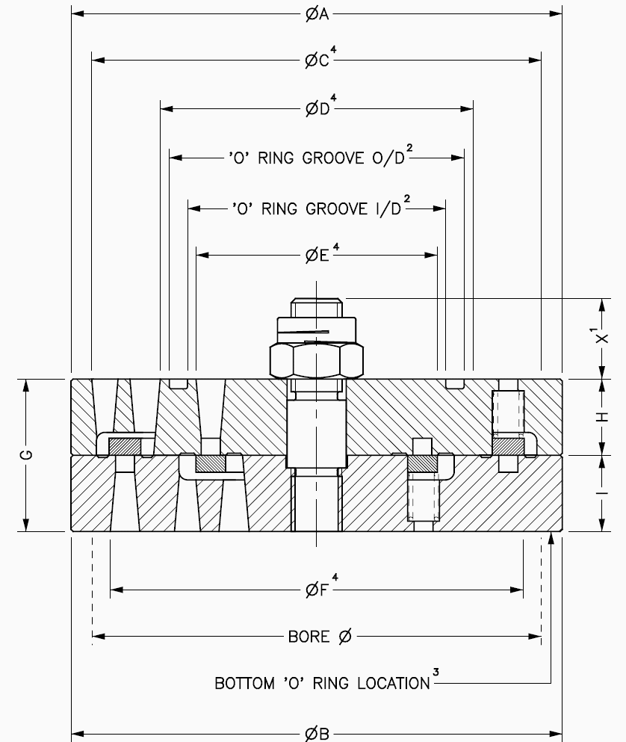 |  |  |  |  |  | 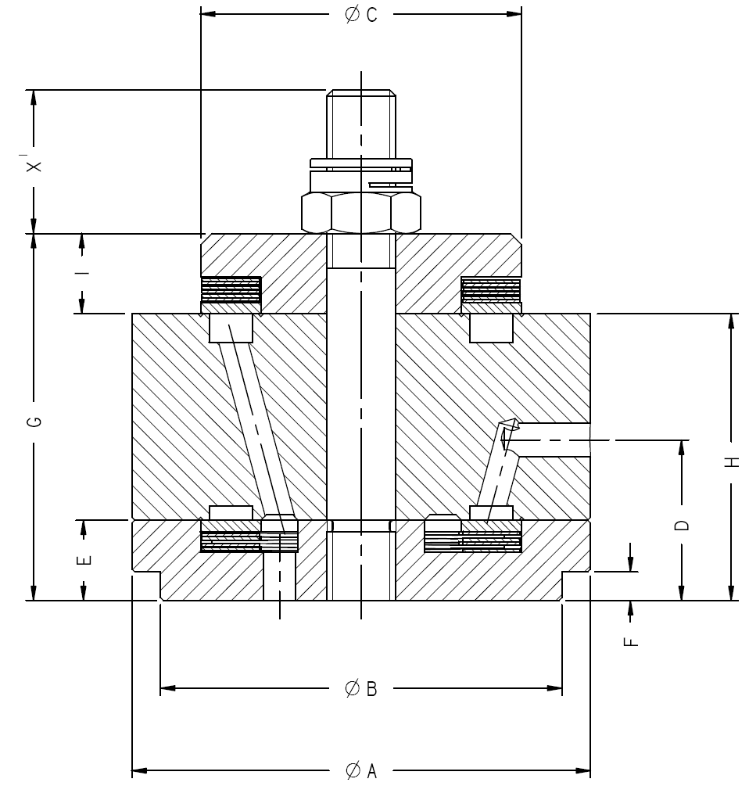
STAGE | 1 |  | 2 | 3 |  | STAGE | 1 |  | 2 | 3
A |  |  |  |  |  | A
B |  |  |  |  |  | B
C⁴ |  |  |  |  |  | C
D⁴ |  |  |  |  |  | D
E⁴ |  |  |  |  |  | E
F⁴ |  |  |  |  |  | F
G |  |  |  |  |  | G
H |  |  |  |  |  | H
I |  |  |  |  |  | I
X¹ |  |  |  |  |  | X¹
Size & Thd.¹ |  |  |  |  |  | Size & Thd.¹
Groove I/D2 |  |  |  |  |  | Groove I/D2
Groove O/D2 |  |  |  |  |  | Groove O/D2
O Ring Section2 |  |  |  |  |  | O Ring Section2
Groove I/D3 |  |  |  |  |  | Groove I/D3
Groove O/D3 |  |  |  |  |  | Groove O/D3
O Ring Section³ |  |  |  |  |  | O Ring Section³
1 - Center Stud Data 2 – Top Face O Ring Data 3 – Bottom Face O Ring Data (If fitted) 4 – Porting Diameters

